5 Project Development

Introduction
This phase describes implementation.
This section explains the phase in a clear and structured manner so that it can be uploaded directly to GitHub as part of a phase-wise academic submission. The content provides enough detail for a one-page document while keeping the explanation simple and professional.

Milestone 1
Created the Standard Laptop Task Flow using Flow Designer.
This section explains the phase in a clear and structured manner so that it can be uploaded directly to GitHub as part of a phase-wise academic submission. The content provides enough detail for a one-page document while keeping the explanation simple and professional.

Milestone 2
Assigned the Flow to the Standard Laptop catalog item.
This section explains the phase in a clear and structured manner so that it can be uploaded directly to GitHub as part of a phase-wise academic submission. The content provides enough detail for a one-page document while keeping the explanation simple and professional.

Milestone 3
Placed a sample order, approved it, and verified automatic Catalog Task creation.
This section explains the phase in a clear and structured manner so that it can be uploaded directly to GitHub as part of a phase-wise academic submission. The content provides enough detail for a one-page document while keeping the explanation simple and professional.

Development Outcome
The completed workflow reduces repetitive manual work and improves efficiency.
This section explains the phase in a clear and structured manner so that it can be uploaded directly to GitHub as part of a phase-wise academic submission. The content provides enough detail for a one-page document while keeping the explanation simple and professional.

Phase 5 – Project Development Screenshots
The following screenshots are captured from the project demonstration video.

ServiceNow Dashboard
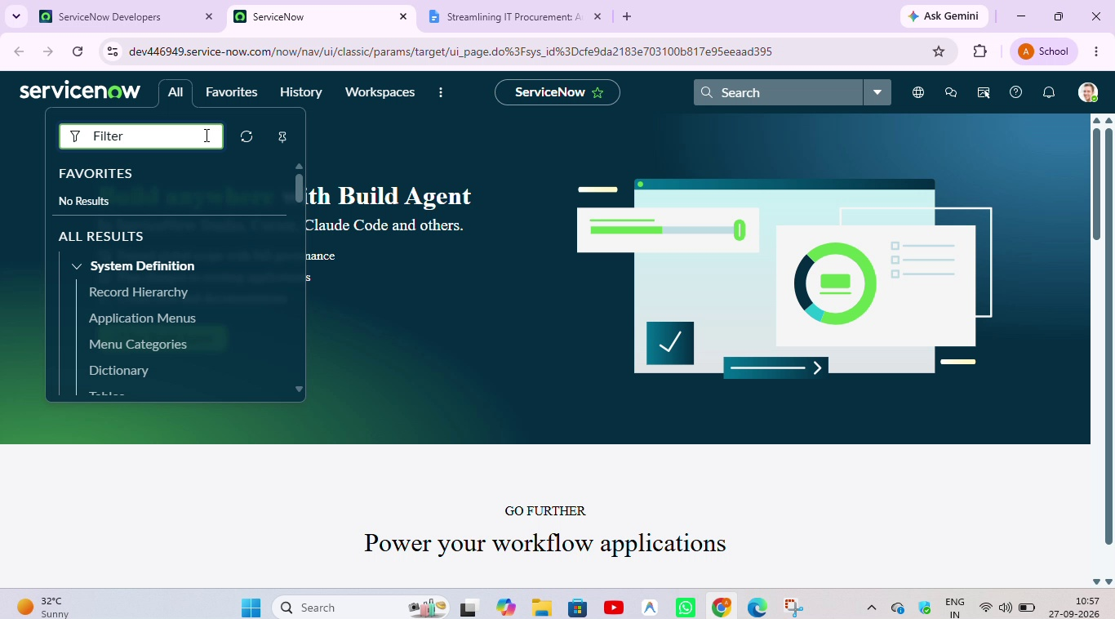
Figure: ServiceNow Dashboard

Catalog / Procurement List
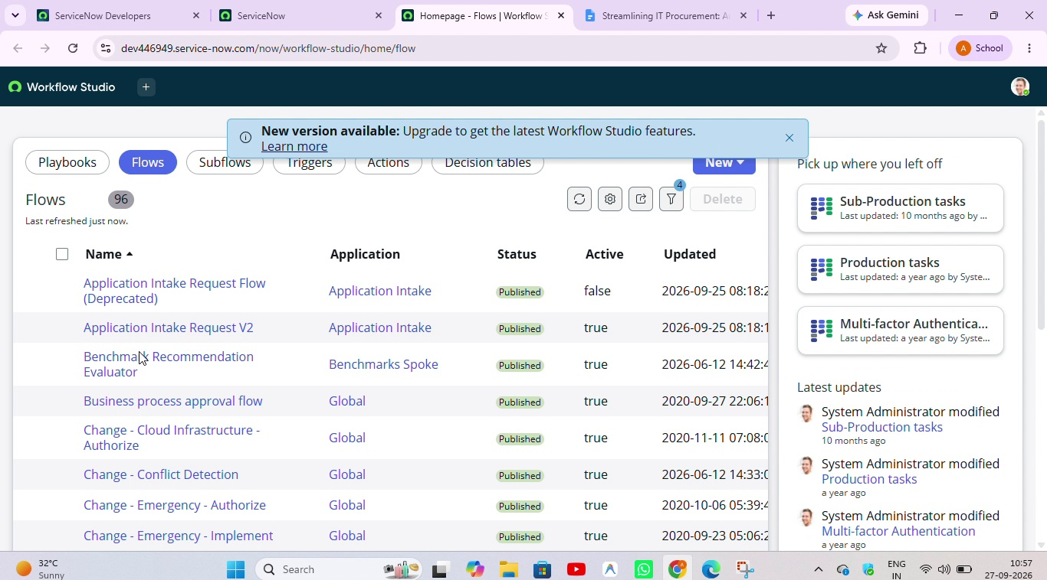
Figure: Catalog / Procurement List

Request Form
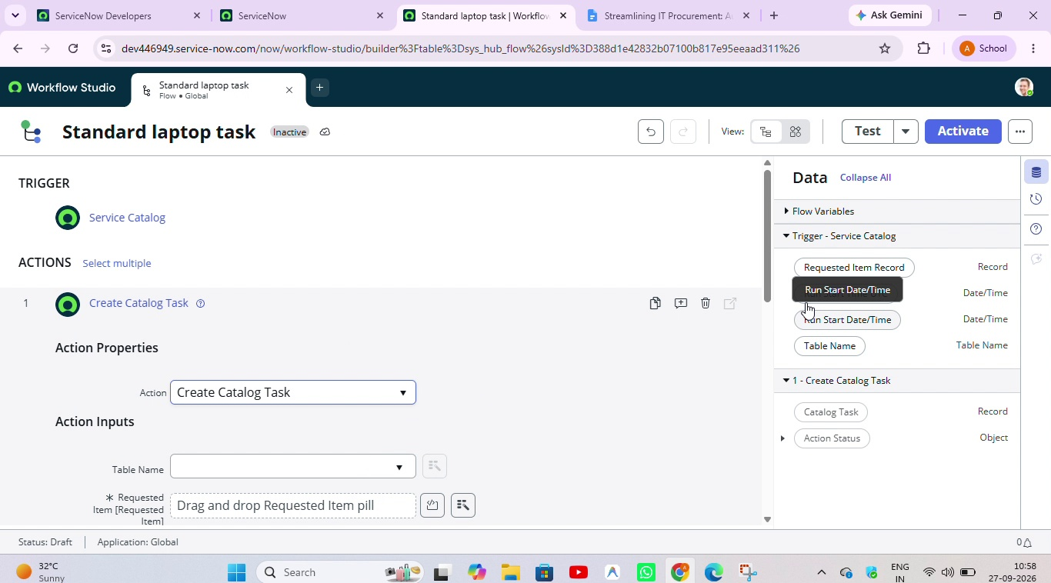
Figure: Request Form

Workflow Configuration
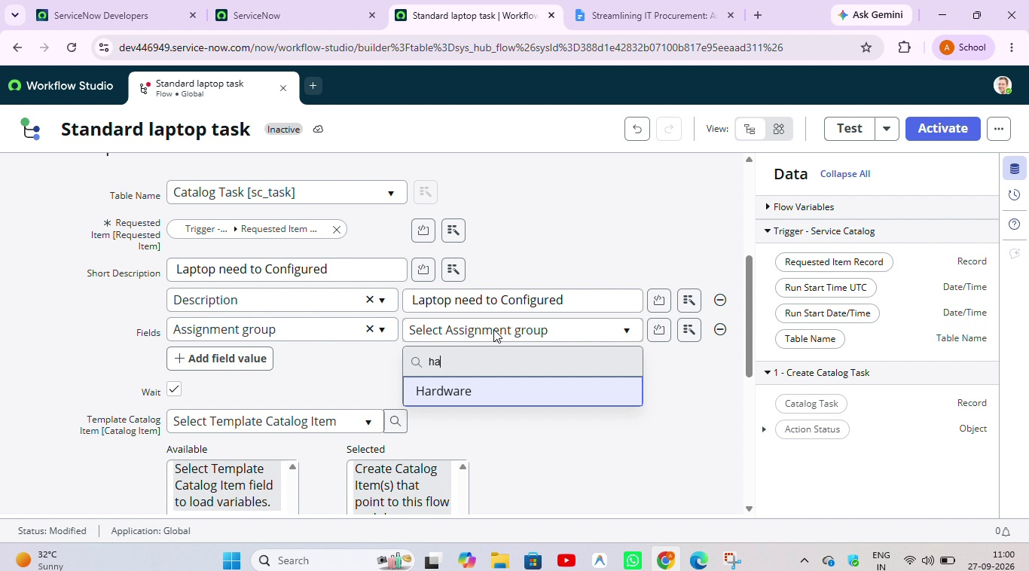
Figure: Workflow Configuration

Approval Workflow
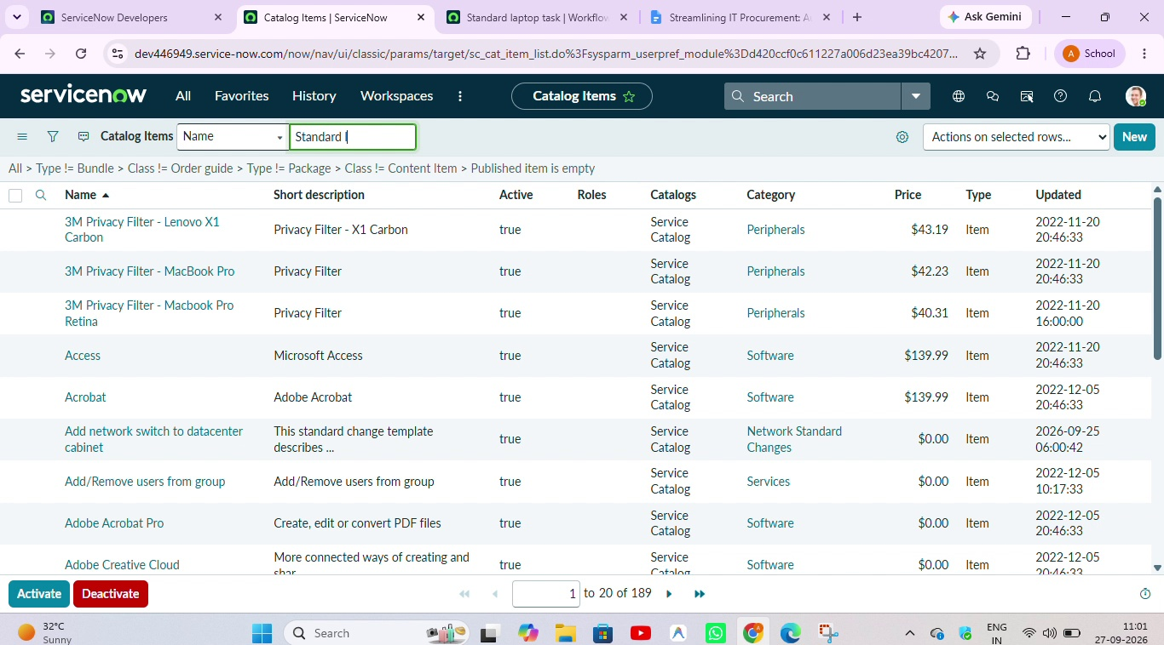
Figure: Approval Workflow

Final Request / Order View
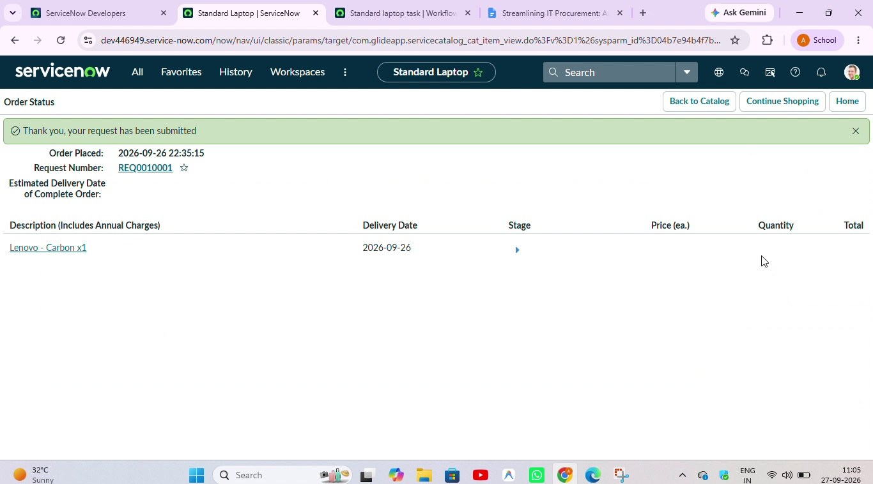
Figure: Final Request / Order View

